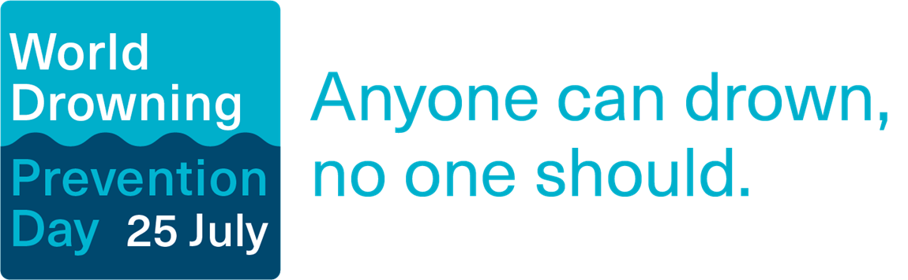
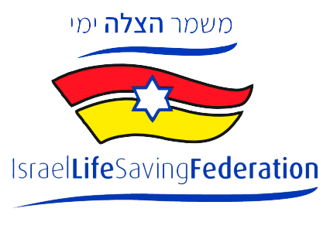

Anyone can drown - no one should

Israel marks World Drowning Prevention Day

JULY 26, 2022 - Hundreds of people drown in Israel every year. During the 2021 bathing season, 248 people drowned or nearly drowned, and 40 people died. Half of all drownings were children. So far during the 2022 bathing season, which began in April, 20 people have died and about 100 have nearly drowned on Israel's beaches, pools, waterways and reservoirs.

Israel Lifesaving Federation in cooperation with the Australian Embassy in Israel marked this day with special events to showcase safe behavior at sea and tools to save lives in cases of drownings.

Globally, 1.2 million people drown every year, making it the “the third leading cause of unintentional injury death,” in the words of the UN General Assembly. It is the second leading cause of death for children ages 9-14. The UN declared International Drowning Prevention Day in order to raise awareness of the dangers of the sea as well as promote proper lifesaving skills and behavior critical in preventing the next drowning. Israel currently has no national plan for education to prevent drowning.

Israel’s beaches stretch over 350 kilometers over four different seas, only 17 kilometers of which are patrolled. Most drownings occur on unpatrolled beaches, and 60% of cases occur when lifeguards are off duty.

This is a segmentation of drownings in Israel in 2021:

- The Sea of Galilee (Kinneret): 13
- The Dead Sea: 22
- The Red Sea: 6
- Mediterranean Sea: 126

So far during the 2022 bathing season, 20 people have lost their lives after drowning in Israel, and another 105 have needed medical aid from Magen David Adom after nearly drowning.

The Israel Life Saving Federation in cooperation with the Australian Embassy in Israel marked World Drowning Prevention Day on July 26 with a demonstration by the organization’s child participants at the Australian ambassador’s Herzliya residence.

People attending the event at the Herzliya residence of Australian ambassador to Israel Paul Griffiths included Yeah Atid MK Simon Davidson, Speedo Israel CEO Ilan Ben Dror, former Olympic swimmer and Issta Sport founder Yoav Bruck, JNF-Australia representative in Israel Gideon Shavit, Royal Moroccan Life Saving Federation board member Mounia Melhaoui, and Israel Life Saving Federation CEO Paul Hakim.

Israel Lifesaving Federation - Education, Safety and Aquatic Rescue

Israel Lifesaving Federation (ILSF) is a non-profit organization whose goal is to save lives through education, prevention and rescue. It has a focus on educating the younger generations in particular for safety and aquatic awareness. The organization, founded by immigrants from Australia, operates under the European and global lifesaving association, and operates programs according to the Australian surf lifesaving rescue model - the leading model in the world. The organization is based on knowledge accumulated over decades in Australia and has been shown to be effective in working with children and adolescents. The programs are age-appropriate for learners and in all of them the trainees learn to recognize the sea and its dangers, to deal with situations of distress and in the end, to provide assistance to another person in a life-threatening situation. The purpose of surf lifesaving communities is to prevent drownings on beaches, pools and other water sources.

ILSF's education programs are aimed at the entire population from the age of 7. ILSF holds activities throughout the year. In addition to aquatic rescue programming, activities also include education on the marine environment, water sports competitions and other enrichment activities for children and youth. The organization’s activities provide participants with an increased awareness of taking responsibility, environmental awareness, and promoting a healthy and safe life and raising the level of safety on the beaches.

Members of the public from ages 7 and up are invited to sign up for ILSF workshops and courses in order to learn best practice rules for swimming in the ocean and how to offer first aid when someone is drowning.
Paul Hakim, President of the Israel Lifesaving Federation: "For the first time, the UN recognizes drownings as a global emergency. The situation in Israel today is very serious. The solution has been around for over 50 years in Australia and has been proven to be a lifesaver. Australian Surf Life Saving Association is the largest voluntary movement in Australia. It numbers over 70,000 volunteers who rescue about 11,000 bathers each year. Our vision is to bring Australian water safety culture to Israel, while building communities and promoting social values."
Mr Paul Griffiths, Australian Ambassador to Israel: "Australia is proud to have in Israel one of its greatest exports – surf lifesaving! The iconic Australian Surf Life Saving Association is a world leader in water safety and drowning prevention. The SLSA cultivates a water safety culture, manages a network of volunteers patrolling beaches, educates youth to lead healthy and responsible lives, promotes confidence and leadership and generally enhances beach safety. I welcome the Israel Life Saving Federation’s initiative to import this vision and knowledge to the beautiful shores of Israel. Our countries have much in common and this provides another fertile area for cooperation.”
Haim Bibas, Chairman, The Federation of Local Authorities: "I welcome the activities of the Israel Life Saving Federation, which has set itself the goal of educating the younger generation and helping coastal authorities deal with cases of drowning at sea, and eradicating the phenomenon. Awareness of dangers, education for responsible behavior at sea and providing tools for safe behavior can save lives. Coastal authorities are working to protect the coastal environment and in particular the lives of sea bathers.”
###
MEDIA KIT: IMAGES AND VIDEOS AVAILABLE FOR USE HERE

For more information about ILSF programs, please contact:
Paul Hakim, President, ILSF
+972-52-857-7666
paul@israellifesaving.org

For media enquiries:
Sarah Vanunu
+972-54-547-4306
sarahvanunu@gmail.com

