ISRAEL LIFE SAVING FEDERATION AND ROYAL MOROCCAN LIFE SAVING FEDERATION TO SIGN HISTORIC MOU AT MACCABIAH GAMES

(JULY 19, TEL AVIV) On Wednesday July 20th at 11:00AM, in the spirit of the Abraham Accords, an MOU will be signed between the Israel Life Saving Federation (ILSF) and Royal Moroccan Lifesaving Federation (RMLF), whose representatives have arrived in Israel especially to take part in a series of sport lifesaving events and activities, where the highlight will be the 2022 Maccabiah.
The Moroccan delegation is composed of International Instructor and Board Member Mrs. Mounia Melhaoui, International Instructor and Treasurer of the Federation Mr. Omar Akik and International Instructor of Instructors and Technical Director of the Federation Mr. Mohamed Rharbal.
As an initiative of the ILSF, Maccabi World Union has introduced Competitive Lifesaving Sports as a new exhibition sport in the 2022 Maccabiah. The events are hosted by the ILSF, a nonprofit volunteer-based organization and member of the International Life Saving Federation (comprised of 148 national federations), that seeks to prevent drownings through education and practical courses for all age groups.
The MOU signing comes a week after a series of chaotic days on Israel’s beaches and waterways, as medics rushed to a seemingly endless string of drownings and near-drownings that left many in critical or serious condition, including several children. A total of 20 people have died in Israel from drowning since the start of the beach season on April 16. During the 2021 swimming season, there were 40 drowning deaths in Israel, and another 208 near-drownings that needed medical assistance.

Competitive Lifesaving at the 2022 Maccabiah
Surf lifesaving competitions will be held for the first time on July 20th and 21st at Poleg Beach, Netanya, at the Maccabiah Village, as an exhibition sport, which is open to athletes from around the world.
Lifesaving sports activities consist of elements of rescue, such as speed of reaction, running, swimming or board paddling towards a person at sea and back with them in the shortest time. The competitions consist of performing various tasks such as those performed by lifeguards at the beach (runners, paddlers, swimmers.)
Israelis and Moroccans are scheduled to participate in Poleg Beach this week alongside participants from around the world including, Australia, France, Singapore, South Africa, and Poland. In addition, the event will be judged by judges of the International Life Saving Federation from Morocco, Germany and England.

Abraham Accords - Surf Lifesaving Collaboration
The momentous MOU signing is to be attended by officials and dignitaries from Israel, Morocco and Australia including Deputy Director General, Israel Ministry of Regional Cooperation, Mr Amit Efrati, Head of the Liaison Office of the Kingdom of Morocco, Mr. Abderrahim Beyyoudh, Acting Ambassador, Embassy of Australia in Israel, Mr. Matthew Wise, MK Simon Davidson, and Mayor of Netanya, Miriam Feirberg-Ikar, among others. The Israeli and Moroccan surf lifesaving organizations seek to work together to advance education and life saving programs for the general public, particularly youth in both countries, advancing life saving techniques and water safety awareness, creating global connections, putting drowning prevention on government agendas and building a better and safer world.
The MOU signing within the framework of the Abraham Accords boosts recognition of the importance of drowning prevention, creates partnerships that advance water safety educational programs and surf rescue skills instruction through joint seminars, improves ocean sustainability research, establishes life saving sports regional competitions and most importantly, creates new bonds and friendships that once were not permitted or existed.

As part of the collaboration, ILSF and RMLF intend to hold educational exchanges and sports tours, and form a joint committee to maximize the benefit of this historic agreement and further strengthen ties between the Kingdom of Morocco and State of Israel on a community and cultural level in the years to come.

Paul Hakim, a native of Australia, is CEO and co-founder of ILSF and the visionary behind the MOU.

Hakim took his passion for the beach and Australian surf life saving culture and brought the iconic Nippers program to Israel, together with his brother, Danny Hakim OAM. The ILSF runs year-round water safety and surf rescue programs for children and adults, provides water safety volunteer teams to staff national swimming events, and lobbies Israel’s national and local governments to prevent drownings along the country’s coasts.

Hakim says, “This MOU illustrates the similar and powerful values that the State of Israel and the Kingdom of Morocco share when it comes to creating a shared understanding and proactive approach to water safety management, enhancing a safe and brighter future for the region through educational leadership seminars, exchange programs and sport. Just as important is the breaking down of barriers through new international friendships, fun and educational programs. The Royal Moroccan Life Saving Federation and ILSF have this very same goal in mind: to provide the youth in Morocco and Israel the opportunities to gain the many benefits of participation in surf lifesaving. This will be a historic and extremely significant event that will enhance both our countries' cooperation in the field of drowning prevention and surf rescue skills.”
Chairman of the Royal Moroccan Lifesaving Federation and President of the African Life Saving Confederation, Dr Mohamed Ali Gharbal, says, “By building an international community based on the philosophy of the International Life Saving model, the cooperation will ultimately save lives, break down barriers between peoples, encourage cultural exchange and will lead to peace and respect between nations. By connecting our countries through sport we have the opportunity to develop links and strengthen relationships between people in both Morocco and Israel.”
Deputy Director General, Israel Ministry of Regional Cooperation, Mr Amit Efrati says, “The MOU signing at the Maccabiah Games aims to create an environment of mutual respect between Israel and Morocco through sport, cultural and educational cooperation. This is exactly the kind of regional cooperation we look forward to seeing a lot more of.”
Head of the Liaison Office of the Kingdom of Morocco, Mr. Abderrahim Beyyoudh, says, “In keeping up the momentum of resuming relations and enhancing them further between the State of Israel and the Kingdom of Morocco, the MOU signing boosts recognition of the importance of drowning prevention, creates partnerships that advance water safety educational programs and surf rescue skills instruction through joint seminars.”
Acting Ambassador, Embassy of Australia in Israel, Mr. Matthew Wise, says, “Over 800,000 lives have been saved by Australian Lifesavers since its establishment in 1907 and the movement maintains a community of 180,000 volunteers, representing the largest volunteer movement of its kind in the world. It’s great to see this iconic Australian cultural export taking off in Israel. Bringing people from multiple cultures together on the beach with a single goal — to save lives — is a mission worthy of praise and support.”

Power of Sport

Surf lifesaving carnivals are competitive sporting events which originated in Australia in the early 20th Century. Extremely popular in Australia and New Zealand, they also have a strong presence in Canada, the US and Europe. Eighty years after the ANZAC lifesavers competed in a surf lifesaving carnival on Israel’s Jaffa beach, this historic MOU helps boost the iconic Australian sport on a global stage as part of the 2022 Maccabiah Games. The sport is also vying for a place at the 2028 L.A. Olympics and 2032 Brisbane Olympics.
Background + Collaboration with Ministry of Regional Affairs
Drownings in Israel have been a growing serious issue in the past decade. Every summer, hundreds of Israelis drown or require medical attention after nearly drowning. While drownings affect all sectors in Israel’s society, statistics indicate that most drownings occur in minority sectors including the Arab and Bedouin sectors.

In March this year, the ILSF together with the Surfing 4 Peace club from Jisr al-Zarqa ran a joint surf rescue and water safety course for a large group of youth at Dor Beach and Jisr al-Zarqa Beach with the aim of preventing drownings and saving lives. This was the ILSF’s first class specifically targeting an Arab community, as part of the organization’s goal of fostering coexistence and preventing drownings throughout all sectors of Israeli society.
As Hakim notes, “Per the laws of nature and the elements, there is no distinction in religion, race nor gender when it comes to drowning. The same applies for saving lives."
The Surfing 4 Peace surf club in Jisr al-Zarqa is headed by siblings Muhammad and Hamama Jarban. "This is an important tool in educating values through sports – we have so much in common and it is a shame that people try to emphasize only what’s different," said Hamama Jarban, a professional athlete and Muslim feminist icon who made waves as the face of an Adidas Israel advertising campaign in 2021.

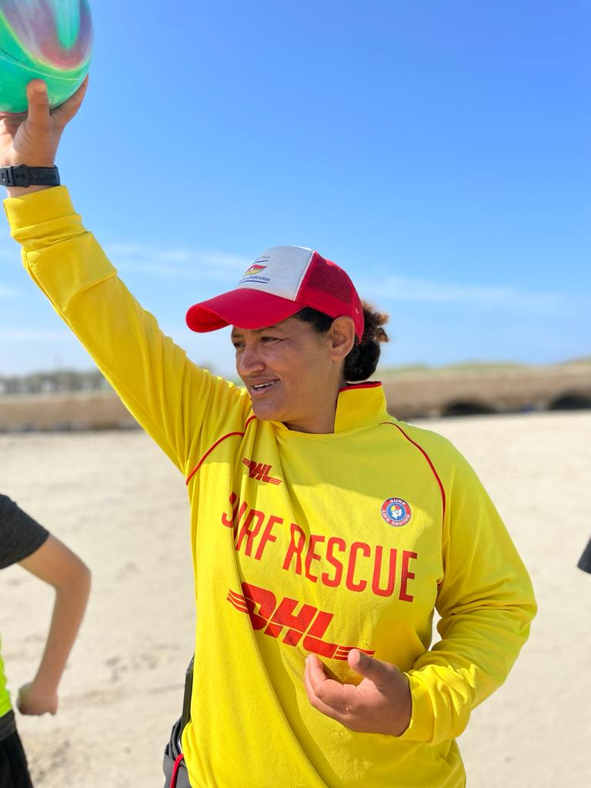
Pictured: Hamama Jarban, Head of Surfing 4 Peace surf club in Jisr al-Zarqa, and a member of the Israel Life Saving Federation

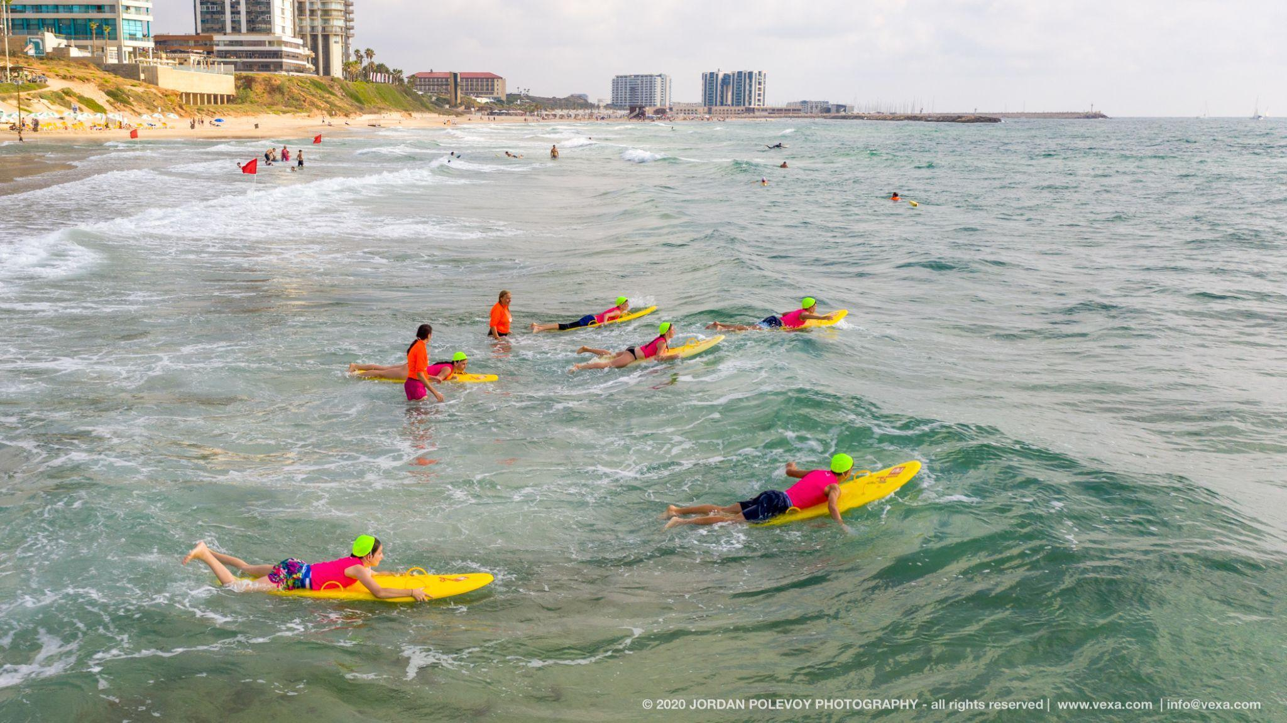
Pictured: Lifesavers in training with ILSF on the beach in Israel. Credit: Jordan Polevoy

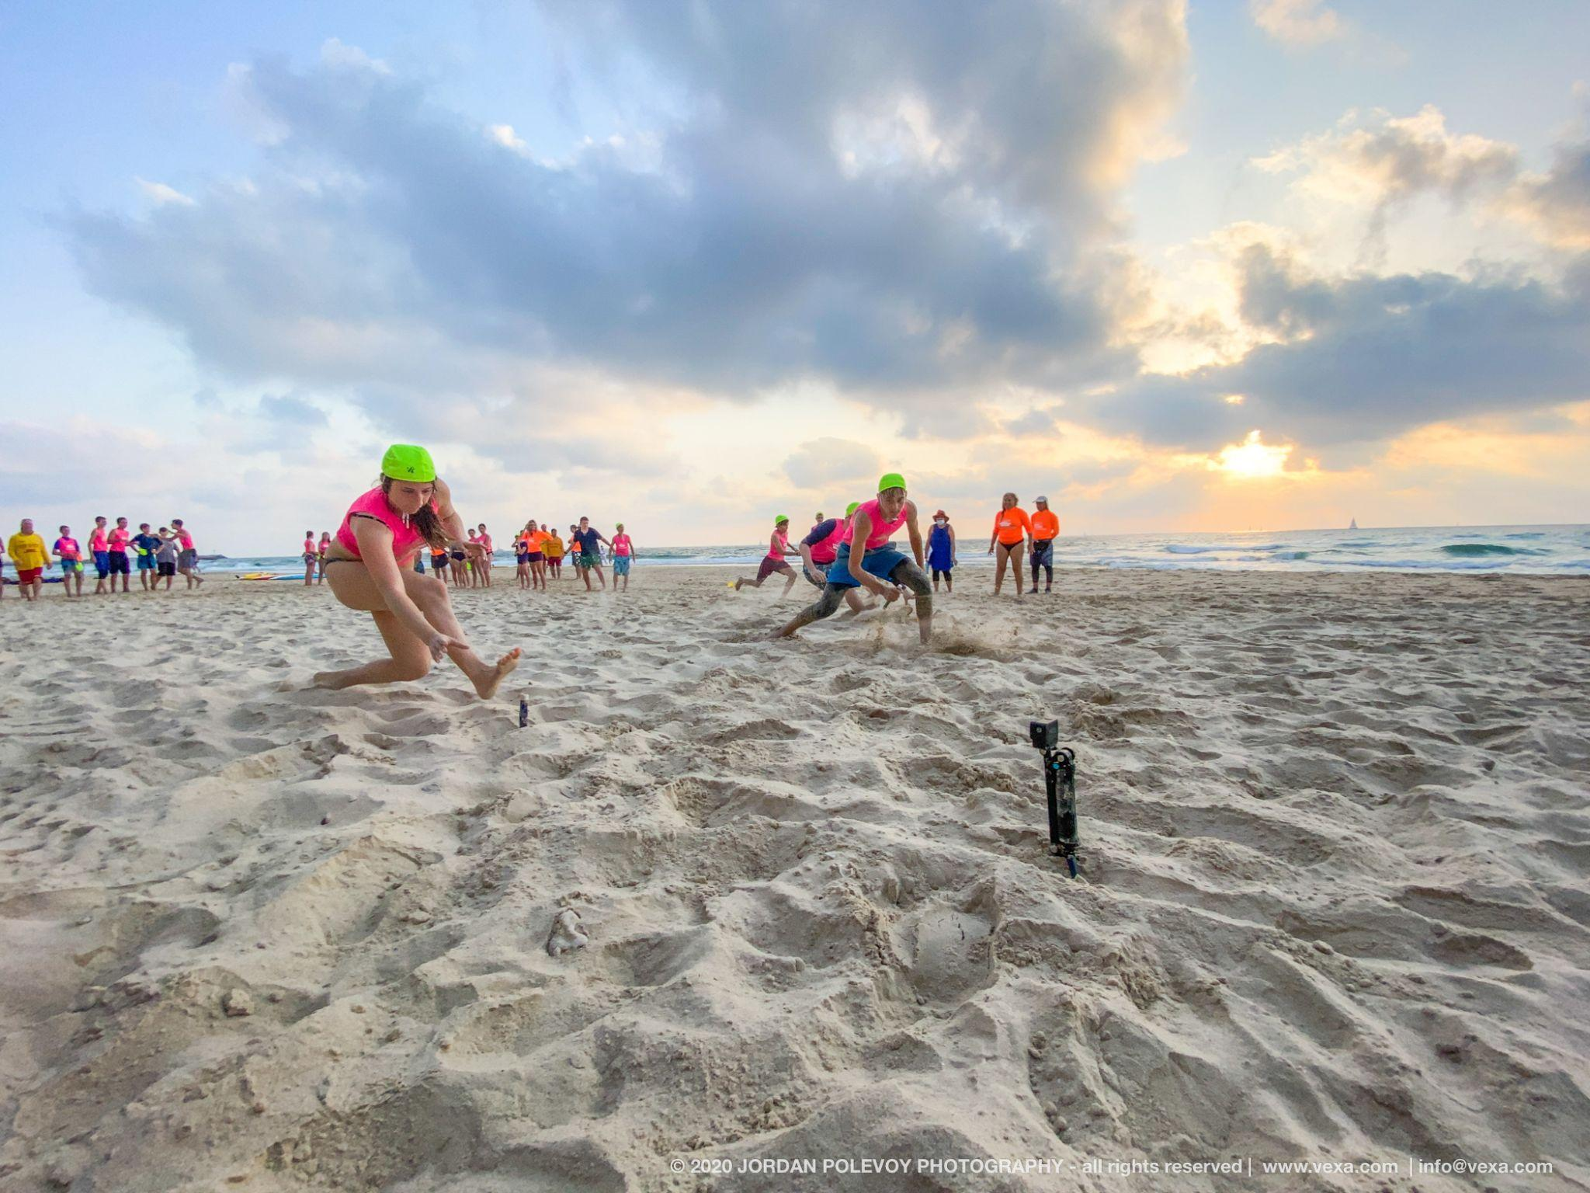
Pictured: Lifesavers in training with ILSF on the beach in Israel. Credit: Jordan Polevoy

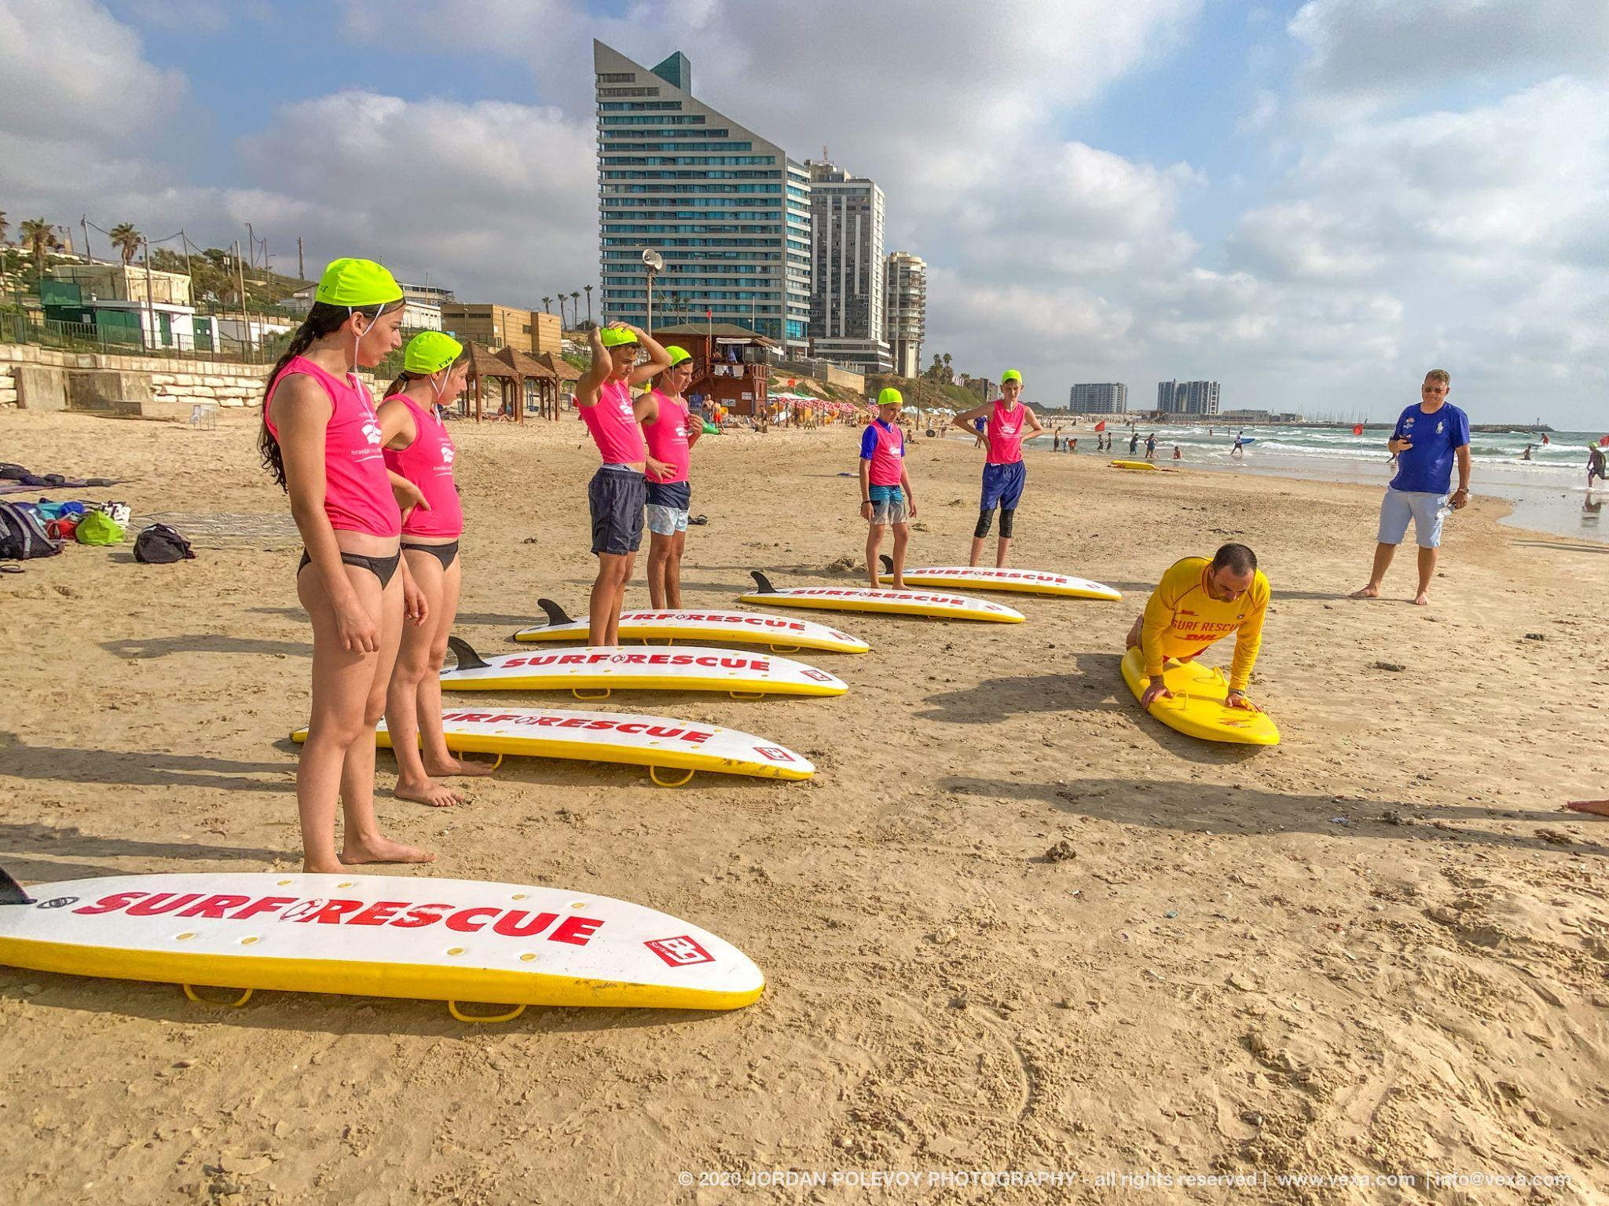
Pictured: Nippers train with ILSF on the beach in Israel. Credit: Jordan Polevoy

The A.I.F. [Australian Imperial Force] Surf Carnival display at Tel-Aviv
1941 October 10. | 1 negative | Matson Photo Service
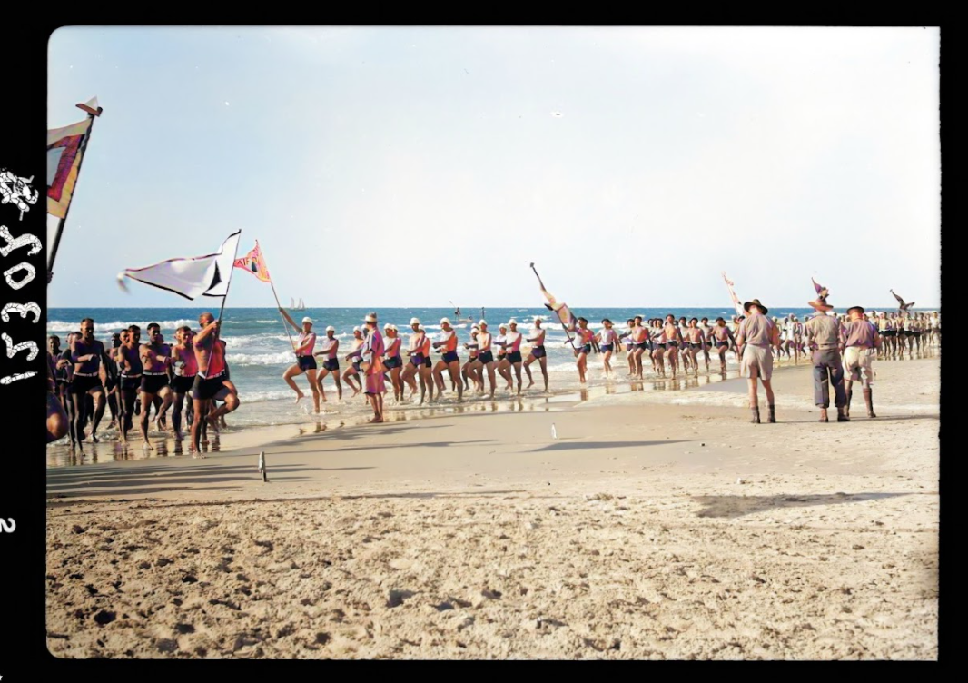
Image restored and colourised by MyHeritage.com

The A.I.F. [Australian Imperial Force] Surf Carnival display at Tel-Aviv
1941 October 10. | 1 negative | Matson Photo Service
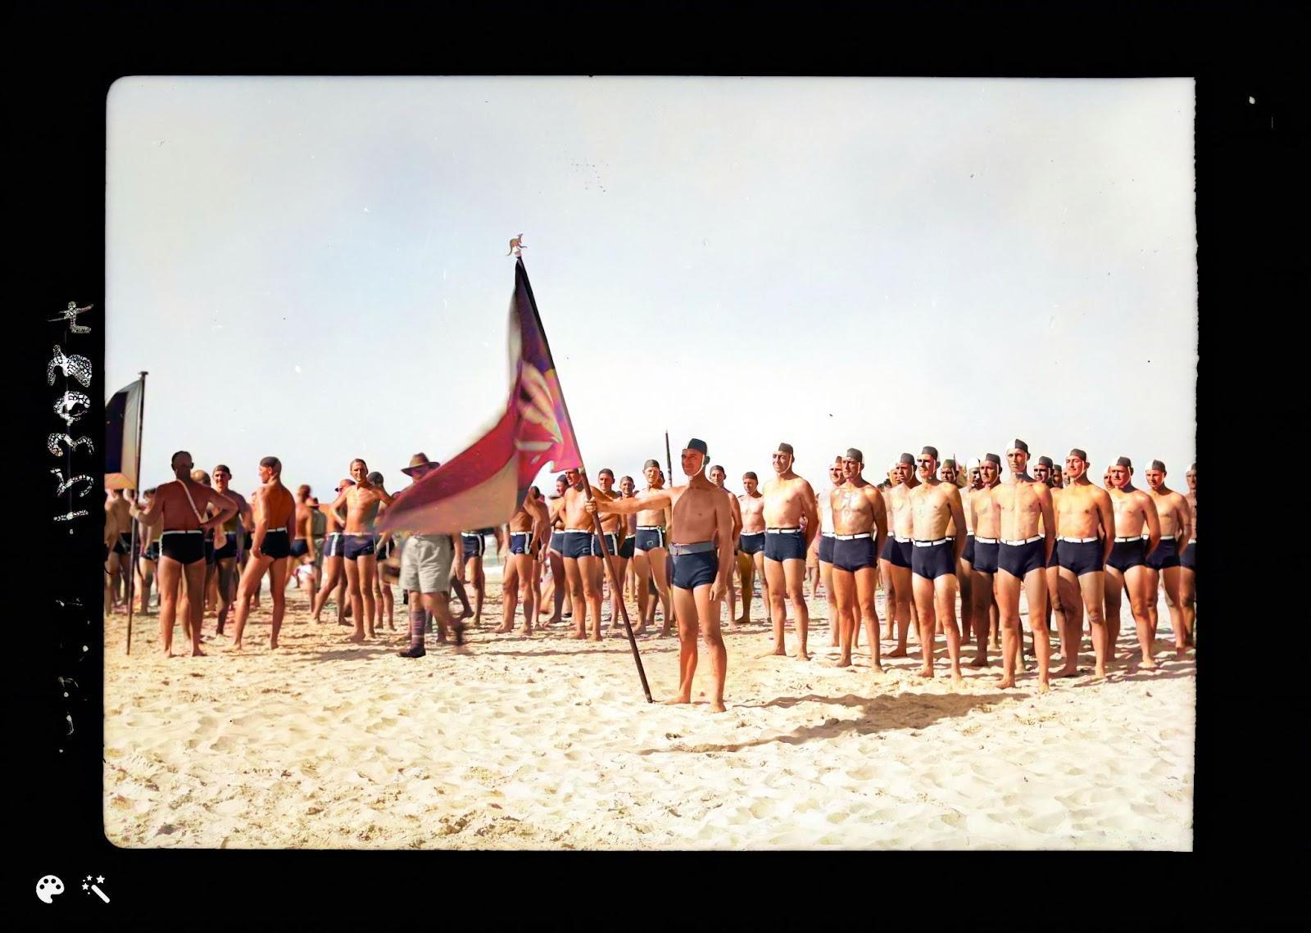
Image restored and colourised by MyHeritage.com

The A.I.F. [Australian Imperial Force] Surf Carnival display at Tel-Aviv
1941 October 10. | 1 negative | Matson Photo Service

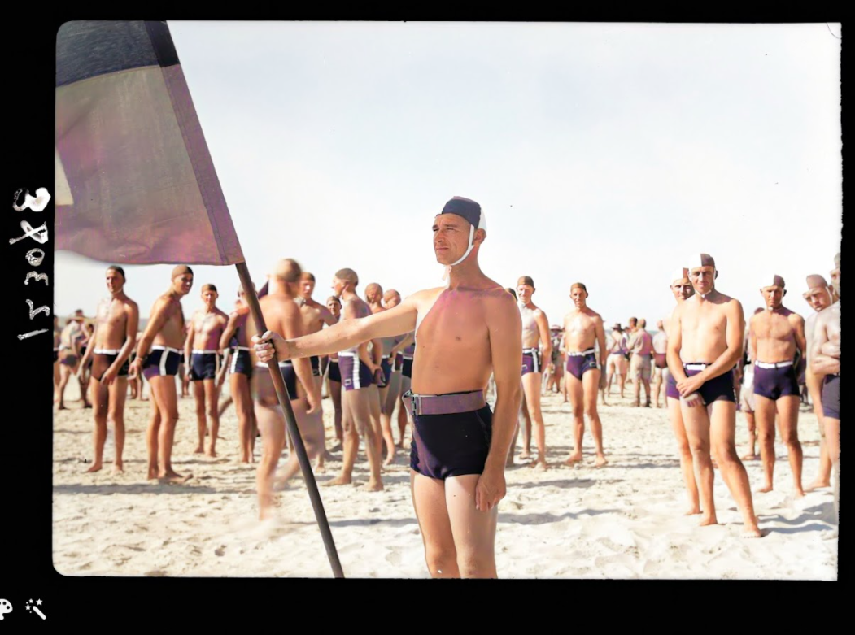
Image restored and colourised by MyHeritage.com
###

About ILSF
Israel Life Saving Federation (ILSF) is an Israeli registered non-profit, community-based volunteer organization whose goal is to prevent drownings across Israel through education and practical courses, and to promote competition lifesaving as a sport in Israel and the region. Founded in 2019, the ILSF is Israel’s local member of the International Life Saving Federation (comprising 148 national federations), the European Life Saving Federation and the Australian Surf Life Saving Association. To date, ILSF course graduates since 2019 have performed more than 70 rescues.

For Media Inquiries (photos, materials, interviews)
Sarah Vanunu, ILSF
+972-54-547-4306 sarahvanunu@gmail.com

Paul Hakim, CEO, ILSF
052-857-7666 paul@israellifesaving.org

Ravit Ben-Amitai, Chairwoman, ILSF
054-980-6767 Ravit.BenAmitai@gmail.com
General information about the Israel Life Saving Federation can be found at www.israellifesaving.org

